U.S. Department of Energy Launches Effort to Grow the Market for Energy Efficiency and Renewable Energy in South Africa

WASHINGTON, D.C— The Department of Energy Office of Energy Efficiency and Renewable Energy (EERE) launched a new initiative to grow a robust market for energy efficiency and renewable energy technologies in South Africa. The initiative is an opportunity for large and small U.S. businesses to better understand the South African business and policy environment, develop relationships with potential business partners, and demonstrate their products in new, developing markets.

The Global Cool Cities Alliance is leading a project team that includes the South African National Energy Development Institute (SANEDI), Lawrence Berkeley National Laboratory (LBNL), University of South Florida (USF), PEER Africa, National Fenestration Rating Council (NFRC), and WinBuild.

Each partner brings a unique set of skills, access, and expertise to the project. LBNL, WinBuild, NFRC, and GCCA offer deep technical expertise and industry connections to a broad group of building envelope material manufacturers and suppliers. USF’s Solar Energy Research Center is a leading expert on a variety of solar energy applications, modeling, and training. SANEDI and PEER Africa provide unparalleled access to South African government representatives, municipal leaders, and key market stakeholders.

The project team will leverage existing relationships and significant progress achieved under the Global Superior Energy Performance Partnership (GSEP) Cool Roofs and Pavements Working Group. After joining the Working Group in January 2013, the South African government has actively pursued a public-private strategy to grow the market and infrastructure for cool surfaces.

“The collaboration is an excellent demonstration of how U.S. technologies can help other nations reach their energy goals. It will spur growth of African markets for energy efficient and renewable energy technologies, providing an opportunity for American companies abroad, while also building a skilled domestic workforce,” said Rob Sandoli, Director of the Department's Office of Energy Efficiency & Renewable Energy International Program..

The project team will publish a series of online guides for American manufacturers and suppliers to detail the opportunities and challenges of the South African market and regulatory environment. The project team will also work with South African stakeholders to test and rate products, share best practices for growing a robust clean energy marketplace, and engage in workforce training to ensure that products are installed and maintained appropriately and develop capacity to manage the system following the initiative’s completion in 2016.

The first demonstration project was carried out by WinBuild, Inc., in partnership with Millennium Roofing Solutions, a small California-based cool coatings manufacturer, and PEER Africa, a prominent developer and partner of a training initiative recognized by the South African Department of Energy called iEEECO™ Flagship Eskom Youth BEAT Program. Working together, the three groups outfitted an affordable home in the !Kheis municipality with a cool, reflective coating, improving living conditions and saving energy.

“The reflective paint has made a very large improvement in temperature in our home,” said Elton Speelman, a recipient of the pilot project’s reflective paint. “My father used to have to take his bed outside to nap because it was too warm inside, but now we can nap inside on a hot day. We are very happy with the paint.”
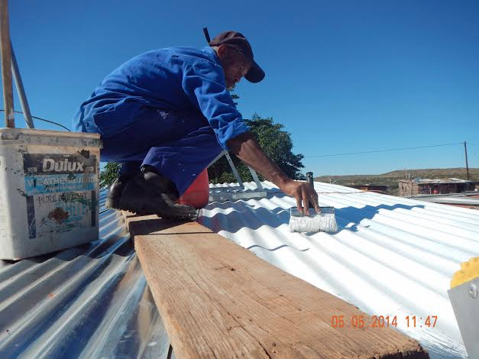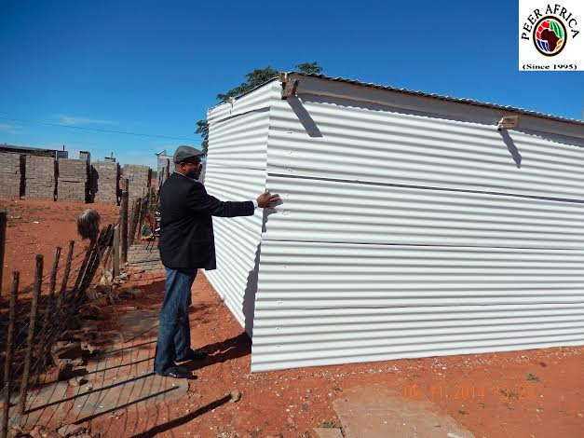
Cool coating applied to new affordable housing structure. Photo: PEER Africa

The initiative goes well beyond heating and cooling, to encourage deployment of other clean energy technologies into the South African market. The project prioritizes in-demand products: solar water heaters, solar PV technologies, LED lighting, daylight harvesting systems, and more.

